Audacity

Audacity is a free and open-source digital audio editor and recording application software, available for Windows, macOS, Linux, and other Unix-like operating systems.[4][5] Audacity was started in the fall of 1999 by Dominic Mazzoni and Roger Dannenberg at Carnegie Mellon University and was released on May 28, 2000 as version 0.8.[7][8]

Download link:

<https://www.audacityteam.org/download/>

Drag and drop the audio file to load it in audacity.

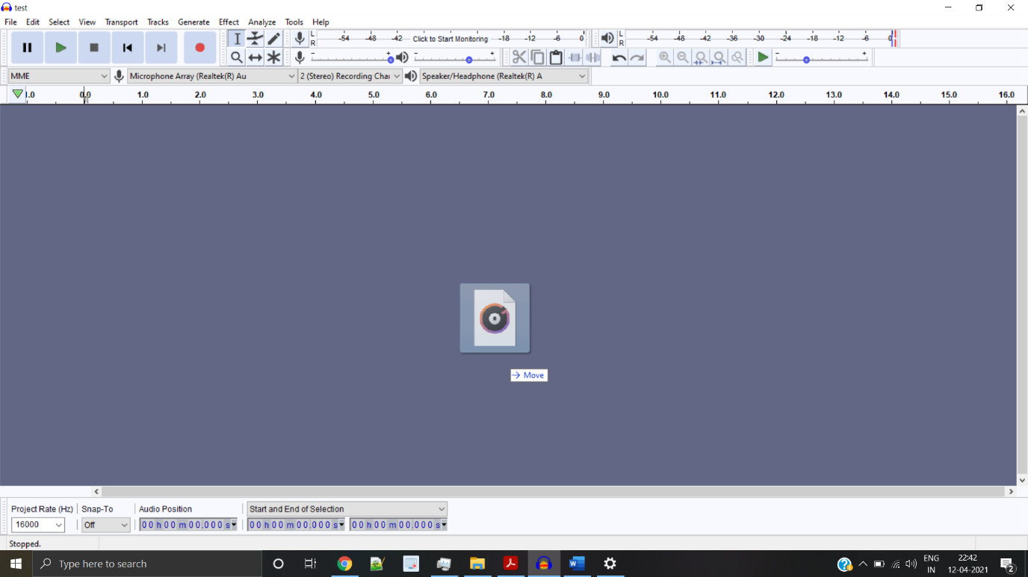

You can look at its waveform.

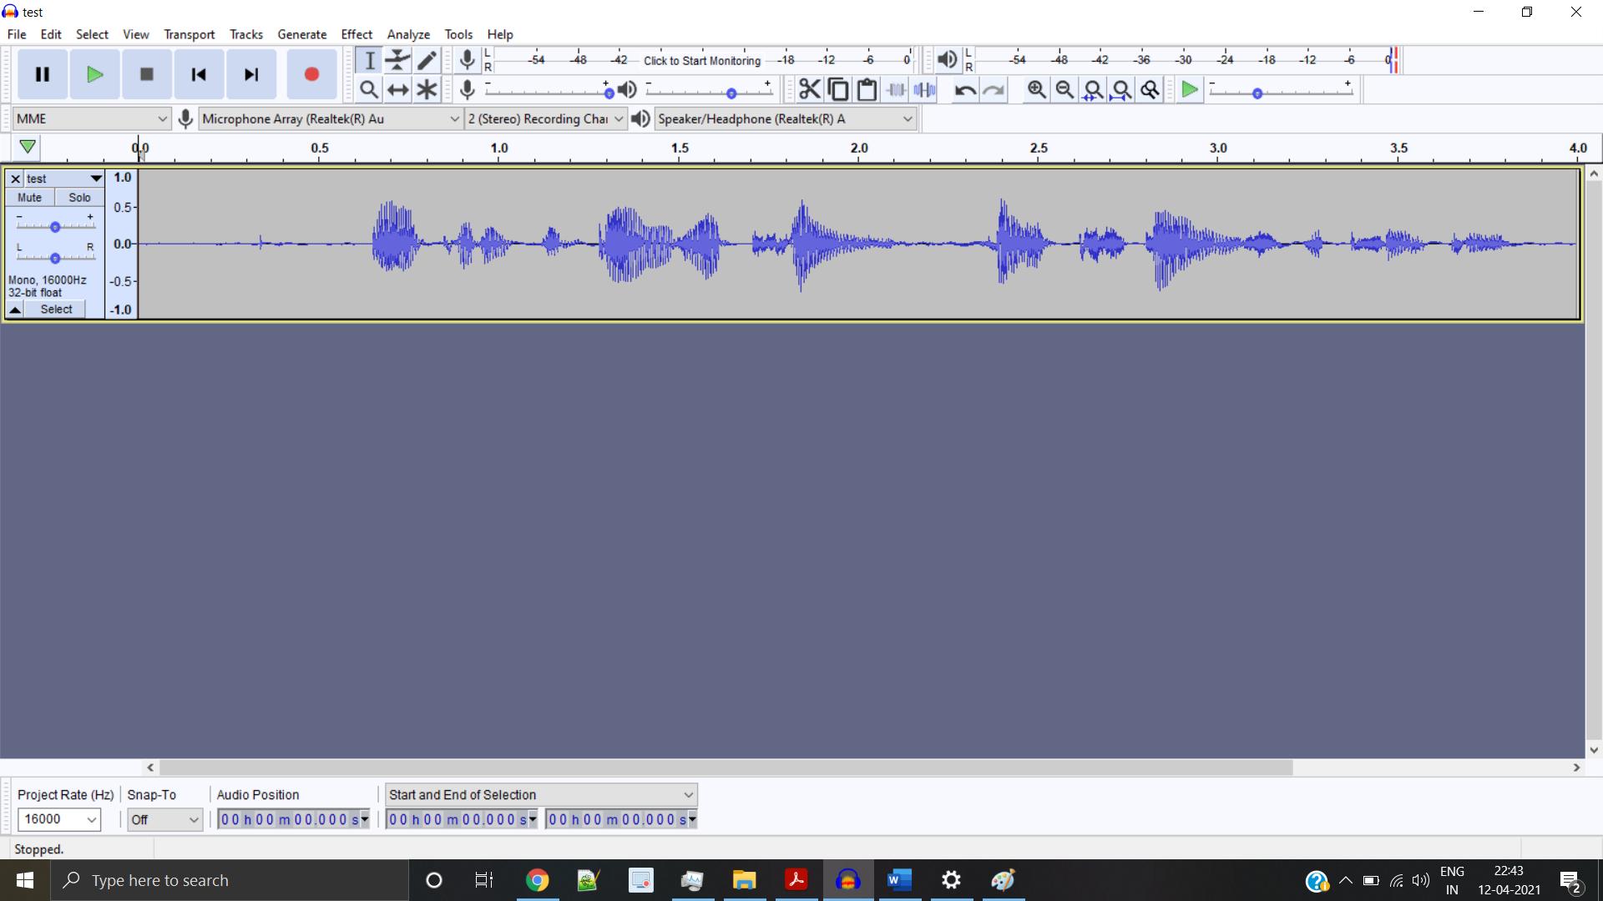

From the menu (the black upside down triangle)

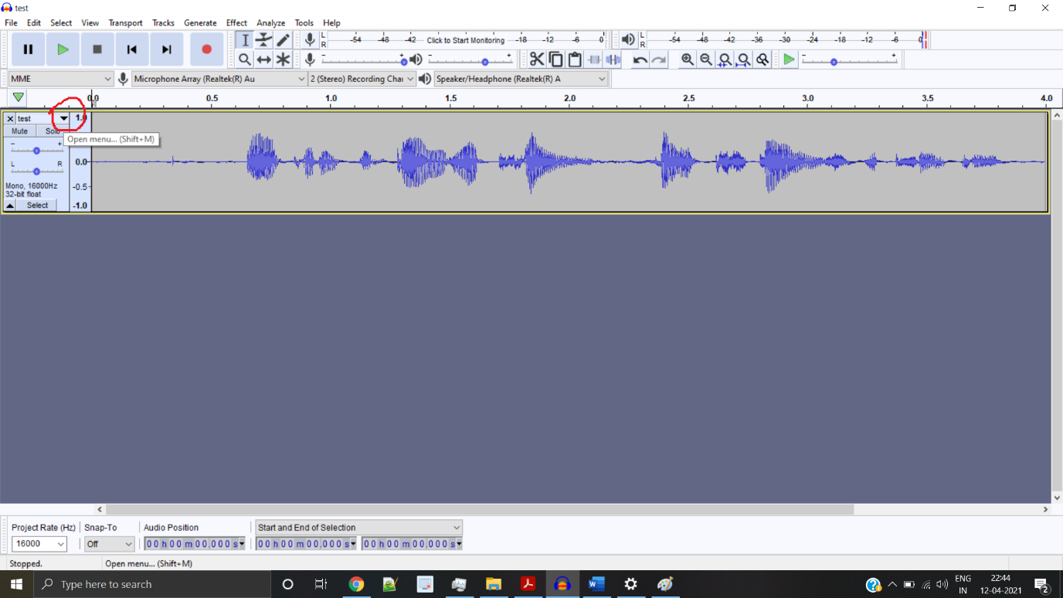

Choose Spectrogram to look at the spectrogram

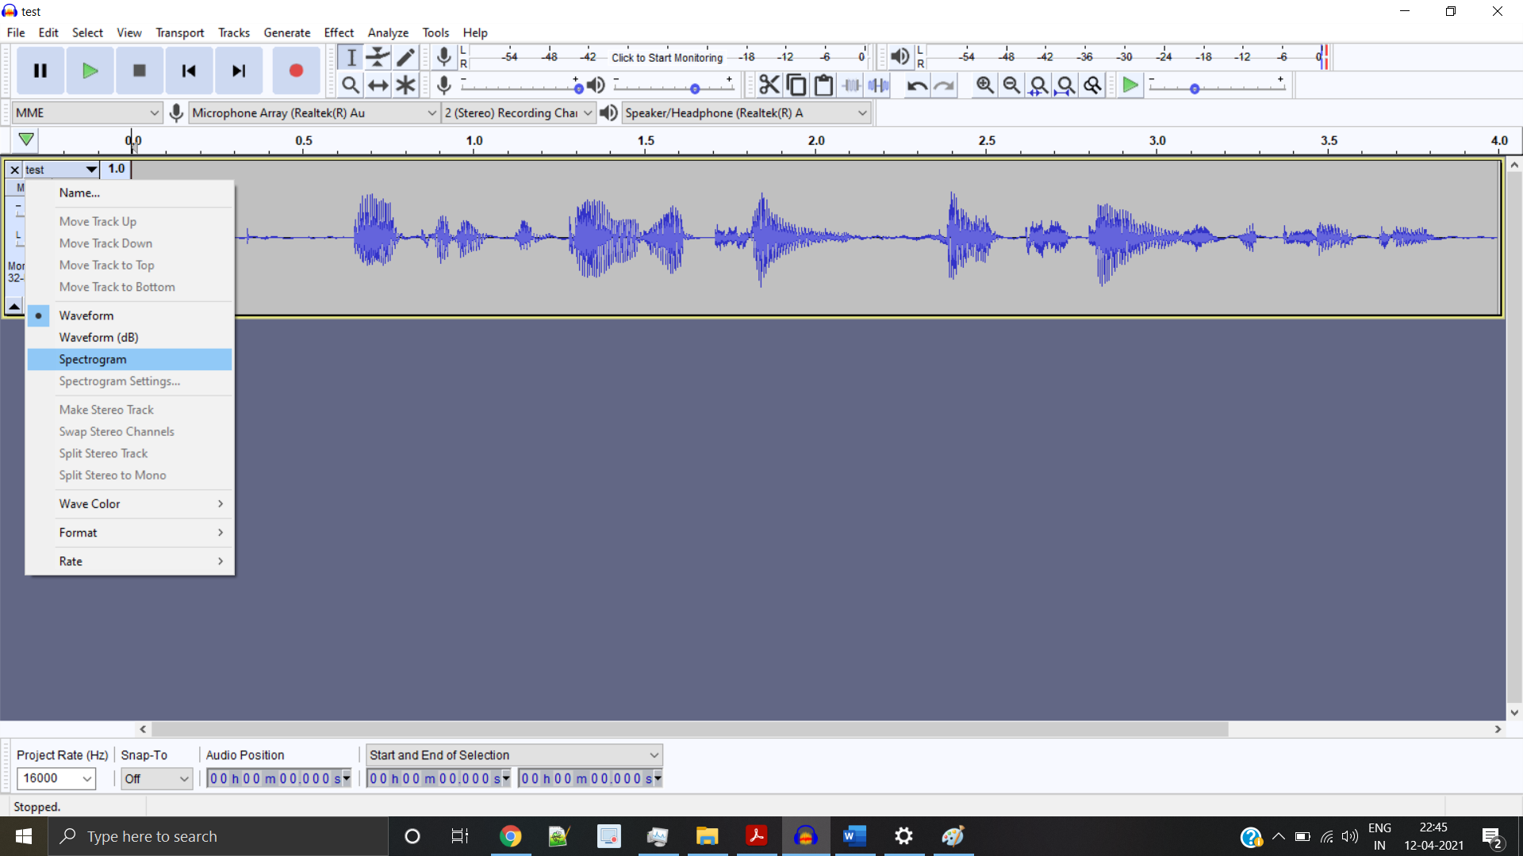

You can edit the spectrogram settings if you want

